Revolutionizing Liver Care : Predicting Liver Cirrhosis Using Advanced Machine Learning Techniques

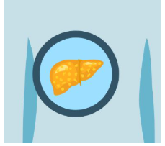

# Team Leader : C Deepthi

# Team member : P Dheekshitha

# Team member : Mallapu Ganesh Kumar

# Team member : P Ganesh

**INTRODUCTION**

Liver cirrhosis, a blood-borne disease, impacts millions worldwide, taking a significant toll on public health. Despite its global prevalence, symptoms often surface only in later stages, contributing to substantial morbidity and mortality rates [1]. According to the World Health Organization (WHO), millions contract the virus annually [2]. The delayed onset of symptoms complicates early detection and intervention efforts, emphasizing the urgent need for innovative diagnostic strategies. The insidious nature of liver cirrhosis, with most patients showing no symptoms in the early stages, underscores the urgent need for effective diagnostic tools. Without early detection, liver damage escalates, leading to heightened fatality rates [3]. Given the absence of a viable vaccination, precise assessment of liver damage becomes pivotal for the effective management and prevention of viral transmission [4]. In this context, AI emerges as a promising tool, demonstrating comparable diagnostic efficacy to human clinicians and, in some cases, surpassing them, particularly among less experienced physicians.

**Project Overview**

Machine learning techniques are being used to revolutionize liver care by improving the prediction of liver cirrhosis, a serious condition where healthy liver tissue is replaced by scar tissue. These techniques allow for early detection, potentially leading to more effective treatment and improved patient outcomes. By analyzing various medical datasets, machine learning models can identify patterns and predict the likelihood of cirrhosis, even at early stages.

**Purpose**

Developing ML models can assist in detecting liver disease early and mitigating its long-term health impacts. Various ML algorithms are assessed for their accuracy and errors in predicting liver cirrhosis based on physiological factors, with RF classification demonstrating superior performance.

**IDEATION PHASE**

|  |  |
| --- | --- |
| Date | 18 July 2025 |
| Team ID | LTVIP2025TMID36105 |
| Project Name | Revolutionizing Liver Care : Predicting Liver Cirrhosis Using Advanced Machine Learning Techniques |
| Maximum Marks | 4 Marks |

Problem Statement

The liver cirrhosis has become a common discase around the world. The death rate due to the disease is becoming alarming. Early detection of the disease may reduce the complication of the disease misfortune on patients. The ease of use of inventive technologies such as the one anticipated in this research may help in alleviating the troubles of holdup in the uncovering and treatment of liver cirrhosis. The Machine learning techniques are used to predict whether patient is positive or negative for the disease. One more significant drive behind this is Predicting Stage also in which stage patient is there.

Empathy Map Canvas:

An empathy map is a simple, easy-to-digest visual that captures knowledge about a user’s behaviours and attitudes.

It is a useful tool to helps teams better understand their users.

Creating an effective solution requires understanding the true problem and the person who is experiencing it. The exercise of creating the map helps participants consider things from the user’s perspective along with his or her goals and challenges.

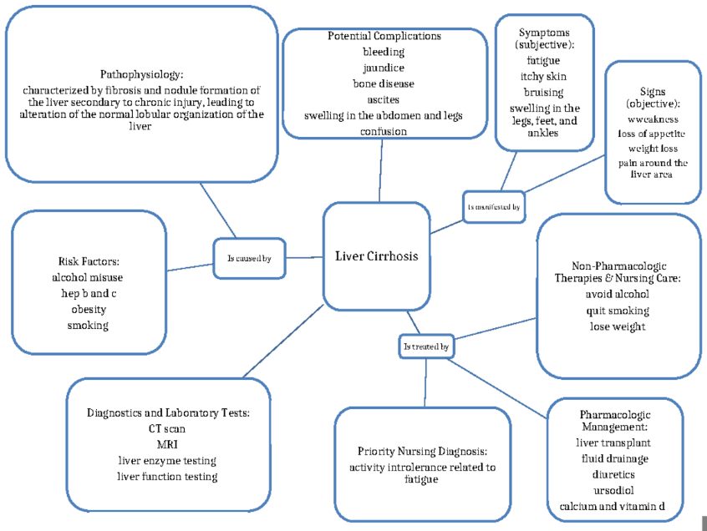

Brainstroming

A good idea for managing liver cirrhosis involves a combination of lifestyle adjustments, dietary changes, and careful medication management, all under the guidance of a healthcare professional. This includes avoiding alcohol, following a low-sodium, healthy diet, and taking medications as directed

It’s important to eat an overall healthy diet that is balanced and full of fruits and vegetables. It's It's important to have protein intake, and that can be from lean sources of protein such as beans or lentils, and salt restriction is also very important.

* Coffee. Coffee lovers will be glad to know that coffee is perhaps one of the best drinks you can have to promote liver health, even if you already have liver problems. ...
* Tea. ...
* Beetroot juice. ...
* Blueberries and cranberries. ...
* Artichokes. ...
* Nuts and seeds. ...
* Grapefruit. ...
* Brussels sprouts and broccoli sprouts.

For people with cirrhosis, it is very important to stop drinking since any amount of alcohol is toxic to the liver. Weight loss. People with cirrhosis caused by metabolic dysfunction-associated steatotic liver disease may become healthier if they lose weight and control their blood sugar levels.

**REQUIREMENT ANALYSIS**

Customer Journey map

Creating a customer journey map for patients with liver cirrhosis involves outlining the stages a patient goes through, from initial awareness of symptoms to ongoing management of the condition. Here’s a structured approach to developing this journey map:

Customer Journey Map for Liver Cirrhosis

• Name: Rajesh

• Age: 55

• Location: pulivendula, India

• Family Status: Married with two adult children

• Occupation: Retired government employee

**Customer Journey Map: Liver Cirrhosis Patient**

**Overall Goal:** To understand the patient's experience from initial symptoms through diagnosis, treatment, and ongoing management, identifying pain points and opportunities for improved care and quality of life.

**Stage 1: Awareness/Pre-Diagnosis (Symptoms & Concerns)**

* **Steps:**
  + Experiencing initial, often subtle, symptoms (e.g., fatigue, weakness, dark urine, unexplained weight gain, abdominal pain, changes in vision, easy bruising, swelling in legs/abdomen).
  + Dismissing symptoms or attributing them to other causes.
  + Self-searching for symptoms online.
  + Discussing symptoms with family/friends
* **Interactions:**
  + **People:** Family, friends, primary care physician.
  + **Places:** Home, workplace, general practitioner's office.
  + **Things:** Internet (health websites, forums), personal observations of body changes.
* **Goals & Motivations:**
  + "Help me feel better/reduce discomfort."
  + "Help me avoid serious illness."
  + "Help me avoid being a burden to others."
* **Positive Moments:**
  + Initial recognition of symptoms leading to seeking help.
  + Support from family/friends encouraging medical consultation.
* **Negative Moments:**
  + Uncertainty and fear about unexplained symptoms.
  + Dismissing serious symptoms.
  + Symptoms fluctuating and making daily life unpredictable.
* **Areas of Opportunity:**
  + Public health campaigns to increase awareness of early liver disease symptoms.
  + Tools for self-assessment of symptoms to prompt earlier medical consultation
  + **Stage 2: Diagnosis**
* **Steps:**
  + Initial consultation with a doctor (GP).
  + Undergoing various tests (blood tests like liver function, CBC, coagulation panel; imaging like CT, ultrasound, MRI, elastography; upper endoscopy; liver biopsy).
  + Waiting for test results.
  + Receiving the diagnosis of liver cirrhosis.
  + Referral to a specialist (gastroenterologist/hepatologist).
* **Interactions:**
  + **People:** GP, nurses, lab technicians, specialists (hepatologist), radiologists.
  + **Places:** Clinics, hospitals (A&E/ER, wards), diagnostic centers.
  + **Things:** Medical equipment, test results, hospital information systems.
* **Goals & Motivations:**
  + "Help me get an accurate diagnosis."
  + "Help me understand the disease."
  + "Help me find the right doctor."
  + "Help me feel supported during this difficult time."
* **Positive Moments:**
  + Finally getting a diagnosis after uncertainty.
  + Feeling cared for by medical staff.
  + Clear communication from healthcare providers.
* **Negative Moments:**
  + Long waiting times for appointments or test results.
  + Pain or discomfort from diagnostic procedures (e.g., paracentesis, biopsy)
* **Areas of Opportunity:**
  + Streamlined diagnostic pathways to reduce waiting times.
  + Improved communication and educational resources about the disease at diagnosis.
  + Emotional support services or patient navigators at the point of diagnosis.

**Stage 3: Treatment & Management**

* **Steps:**
  + Starting treatment for the underlying cause (e.g., antivirals for hepatitis, lifestyle changes for fatty liver disease, abstinence from alcohol).
  + Managing symptoms and complications (e.g., diuretics for ascites, medications for hepatic encephalopathy, antibiotics for infections).
  + Regular monitoring of liver function and overall health.
  + Adhering to dietary modifications and fluid restrictions.
  + Attending follow-up appointments.
  + Considering advanced treatments (e.g., TIPS, liver transplantation) if needed.
  + Engaging in self-management strategies.
* **Interactions:**
  + **People:** Hepatologist, nurses, dietitians, pharmacists, social workers, transplant team.
  + **Places:** Outpatient clinics, hospitals, pharmacies.
  + **Things:** Medications, dietary plans, monitoring devices, patient portals.
* **Goals & Motivations:**
  + "Help me slow down or stop disease progression."
  + "Help me manage my symptoms."
* **Positive Moments:**
  + Symptom improvement with treatment.
  + Building a trusting relationship with healthcare providers.
  + Feeling empowered by understanding their condition and management.
  + Access to structured nursing care and coordinated care.
* **Negative Moments:**
  + Side effects from medications.
  + Strict dietary and fluid restrictions impacting daily life.
  + Difficulty accessing outpatient care or consistent support.
  + Feeling neglected if the healthcare relationship is not strong.
  + Financial burden of treatment and care.
* **Areas of Opportunity:**
  + Comprehensive patient education programs on disease management.
  + Integrated care teams (nurses, dietitians, social workers) to support patients.
  + Mental health support to address fear, anxiety, and depression.
  + Remote monitoring solutions for ongoing care and early detection of complications.

**Stage 4: Living with Cirrhosis / End-of-Life Care (if applicable)**

* **Steps:**
  + Adjusting to long-term chronic illness.
  + Coping with physical limitations and extreme fatigue.
  + Managing social stigma and isolation.
  + Navigating potential hospitalizations for complications.
  + If applicable, entering palliative or hospice care.
  + Making end-of-life decisions.
* **Interactions:**
  + **People:** Family, friends, support groups, palliative care team, spiritual advisors.
  + **Places:** Home, hospital, hospice facilities.
  + **Things:** Home health services, advance directives.
* **Goals & Motivations:**
  + "Help me maintain independence as much as possible."
  + "Help me find purpose and meaning in my life."
  + "Help me live comfortably and with dignity."
  + "Help my family cope."
* **Positive Moments:**
  + Strong family and social support.
  + Improved quality of life through effective symptom management.
  + Feeling understood and respected in end-of-life care.
* **Negative Moments:**
  + Progressive physical impairment.
  + Loss of independence and social activities.
* **Areas of Opportunity:**
  + Increased access to home health and supportive care services.
  + Psychosocial support for patients and caregivers.
  + Early introduction of palliative care discussions.
  + Resources for advance care planning.

This structured approach allows for a holistic view of the patient's journey, highlighting critical moments and areas where interventions can significantly improve the patient's experience and outcomes.

**Solution Requirements**

The solution aims to assist in the management, monitoring, and potentially the treatment planning for patients with liver cirrhosis. This could encompass a range of tools, from diagnostic aids and patient management systems to lifestyle recommendation engines.

**1. Functional Requirements**

Functional requirements describe what the system *does*.

**1.1. Patient Data Management:**

* **FR1.1.1:** The system shall allow secure creation, retrieval, update, and deletion (CRUD) of patient demographic information (Name, Age, Gender, Contact, Address).
* **FR1.1.2:** The system shall store and retrieve medical history, including past illnesses, surgeries, medications, and allergies.
* **FR1.1.3:** The system shall store and retrieve family medical history relevant to liver disease.
* **FR1.1.4:** The system shall allow for the upload and storage of medical images (e.g., ultrasound, CT, MRI scans of the liver).
* **FR1.1.5:** The system shall allow for the upload and storage of laboratory test results (e.g., LFTs, CBC, INR, creatinine, albumin, bilirubin, sodium).
* **FR1.1.6:** The system shall track and display a chronological history of patient vitals (e.g., blood pressure, heart rate, temperature, weight).

**1.2. Diagnosis and Assessment Support:**

* **FR1.2.1:** The system shall calculate and display standard liver cirrhosis scoring systems (e.g., Child-Pugh score, MELD score, MELD-Na score) based on entered lab values.
* **FR1.2.2:** The system shall provide a tool for inputting clinical symptoms and signs related to liver cirrhosis (e.g., ascites, jaundice, encephalopathy, variceal bleeding).
* **FR1.2.3:** The system shall suggest potential differential diagnoses based on entered patient data and lab results.
* **FR1.2.4:** The system shall highlight abnormal lab values or critical changes in patient status that may indicate progression or complications of cirrhosis.

**1.3. Treatment Planning and Management:**

* **FR1.3.1:** The system shall provide a repository of evidence-based treatment guidelines for different stages and complications of liver cirrhosis.
* **FR1.3.2:** The system shall allow healthcare providers to record and track prescribed medications, dosages, and administration schedules.
* **FR1.3.3:** The system shall allow for the scheduling and tracking of medical procedures (e.g., endoscopy, paracentesis, TIPS).
* **FR1.3.4:** The system shall facilitate the creation and management of follow-up appointments and reminders for patients.
* **FR1.3.5:** The system shall provide recommendations for lifestyle modifications (diet, exercise, alcohol abstinence) tailored to the patient's condition.

**1.4. Monitoring and Progression Tracking:**

* **FR1.4.1:** The system shall generate graphical representations of key lab parameters over time to visualize trends (e.g., bilirubin levels, INR).
* **FR1.4.2:** The system shall alert healthcare providers to significant deviations or rapid declines in patient health indicators.
* **FR1.4.3:** The system shall track and display the history of complications experienced by the patient (e.g., episodes of encephalopathy, variceal bleeds).

**1.5. Reporting and Analytics:**

* **FR1.5.1:** The system shall generate printable patient summaries for healthcare providers.
* **FR1.5.2:** The system shall allow for the generation of aggregated, anonymized data for research and epidemiological studies (with appropriate patient consent and ethical approvals).

**1.6. User Management and Access Control:**

* **FR1.6.1:** The system shall support different user roles (e.g., Administrator, Doctor, Nurse, Patient).
* **FR1.6.2:** The system shall enforce role-based access control (RBAC) to ensure data confidentiality and integrity.

**2. Non-Functional Requirements**

Non-functional requirements describe *how* the system performs.

**2.1. Performance:**

* **NFR2.1.1 (Responsiveness):** The system shall load patient records within 3 seconds.
* **NFR2.1.2 (Throughput):** The system shall support at least 100 concurrent users without significant degradation in performance.
* **NFR2.1.3 (Scalability):** The system shall be scalable to accommodate a growing number of patients and data over time (e.g., through cloud-based infrastructure).

**2.2. Security:**

* **NFR2.2.1 (Data Encryption):** All sensitive patient data shall be encrypted at rest and in transit (e.g., using TLS/SSL).
* **NFR2.2.2 (Authentication):** The system shall implement strong authentication mechanisms (e.g., multi-factor authentication for healthcare providers).
* **NFR2.2.3 (Authorization):** Access to patient data shall be strictly controlled based on user roles and permissions.
* **NFR2.2.4 (Audit Trails):** The system shall maintain comprehensive audit trails of all data access and modifications for accountability.
* **NFR2.2.5 (Vulnerability Management):** The system shall undergo regular security audits and penetration testing to identify and address vulnerabilities.
* **NFR2.2.6 (Compliance):** The system shall comply with relevant data privacy regulations (e.g., HIPAA in the US, GDPR in Europe, local regulations in India like DPDP Act).

**2.3. Usability:**

* **NFR2.3.1 (User Interface):** The user interface shall be intuitive, easy to navigate, and consistent across all modules.
* **NFR2.3.2 (Accessibility):** The system shall adhere to accessibility guidelines (e.g., WCAG 2.1) to accommodate users with disabilities.
* **NFR2.3.3 (Error Handling):** The system shall provide clear and helpful error messages.
* **NFR2.3.4 (Training):** The system should require minimal training for healthcare professionals to use effectively.

**2.4. Reliability:**

* **NFR2.4.1 (Availability):** The system shall be available 99.9% of the time, excluding scheduled maintenance.
* **NFR2.4.2 (Data Backup and Recovery):** The system shall implement robust data backup and disaster recovery mechanisms to prevent data loss.
* **NFR2.4.3 (Fault Tolerance):** The system should be designed to withstand component failures and continue operation.

**2.5. Maintainability:**

* **NFR2.5.1 (Modularity):** The system shall be built with a modular architecture to facilitate future enhancements and bug fixes.
* **NFR2.5.2 (Documentation):** Comprehensive technical documentation shall be provided for system development, deployment, and maintenance.
* **NFR2.5.3 (Code Quality):** The codebase shall adhere to coding standards and best practices.

This comprehensive list covers a wide range of considerations for developing a robust and effective solution for liver cirrhosis management. The specific priority of each requirement may vary depending on the target users, the scope of the solution, and available resources.

**Data Flow Diagrams:**

A Data Flow Diagram (DFD) is a traditional visual representation of the information flows within a system. A neat and clear DFD can depict the right amount of the system requirement graphically. It shows how data enters and leaves the system, what changes the information, and where data is stored.

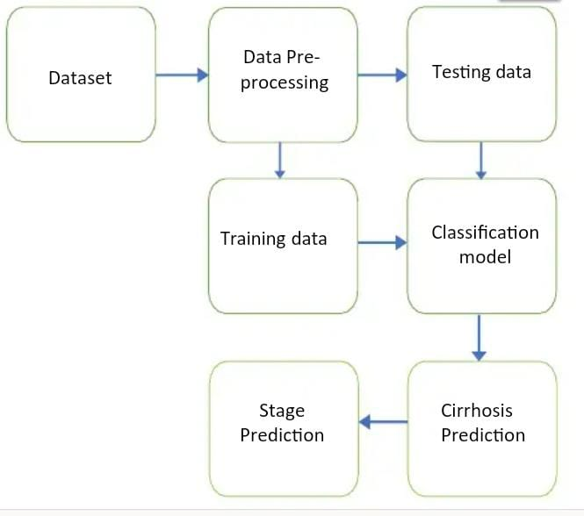

# **PROJECT DESIGN**

Problem Solution Fit

Step 1: Customer Segments

Identify the groups affected by liver cirrhosis:

- Patients diagnosed with liver cirrhosis

- Family members and caregivers

- Healthcare providers (doctors, nurses, etc.)

- Insurance companies and healthcare systems

Step 2: Jobs to be Done / Problems

- Patients: managing symptoms, slowing disease progression, improving quality of life

- Family members and caregivers: supporting loved ones, managing stress, finding resources

- Healthcare providers: providing effective treatment, managing patient care, reducing healthcare costs

- Insurance companies and healthcare systems: reducing costs, improving patient outcomes, managing resources

Step 3: Triggers

1. Diagnosis: Receiving a diagnosis of liver cirrhosis can be a life-altering event that triggers a range of emotions.

2. Symptoms: Experiencing symptoms such as fatigue, jaundice, or abdominal pain can trigger feelings of anxiety and concern.

3. Treatment: Starting or changing treatment plans can trigger emotions related to hope, fear, and uncertainty.

4. Lifestyle changes: Making lifestyle changes such as abstaining from alcohol or changing diet and exercise habits can trigger feelings of frustration and motivation.

5. Social interactions: Interacting with family, friends, and healthcare providers can trigger emotions related to support, stigma, and isolation

Step 4: Emotions

Emotions (Before)

1. Anxiety: Feeling worried or anxious about the diagnosis, treatment, and future outcomes.

2. Fear: Fear of the unknown, fear of death, or fear of losing control.

3. Denial: Denying the severity of the condition or the need for treatment.

4. Anger: Feeling angry or frustrated about the diagnosis, treatment, or lifestyle changes.

Emotions (After)

1. Hope: Feeling hopeful about the effectiveness of treatment and the possibility of improved outcomes.

2. Relief: Feeling relieved after receiving a diagnosis or starting treatment.

3. Empowerment: Feeling empowered to take control of health and make positive lifestyle changes.

Step 5: Available Solutions

- Medications (e.g., diuretics, beta-blockers)

- Lifestyle changes (e.g., abstinence from alcohol, weight loss)

- Surgical interventions (e.g., liver transplantation)

- Alternative therapies (e.g., acupuncture, herbal supplements)

Step 6: Customer Constraints

- Patients: limited access to healthcare, financial constraints, lack of awareness about the disease

- Family members and caregivers: emotional stress, financial burden, limited resources

- Healthcare providers: limited resources, lack of effective treatments, bureaucratic challenges

- Insurance companies and healthcare systems: financial constraints, regulatory challenges, limited resources

Step 7: Behaviour

1. Adherence to treatment: Taking medication as prescribed, attending follow-up appointments, and making lifestyle changes.

2. Self-monitoring: Tracking symptoms, medication, and lifestyle changes.

3. Seeking support: Reaching out to family, friends, healthcare providers, or support groups for emotional support.

Step 8: Channels of Behaviour

1. Mobile apps: Using mobile apps to track symptoms, medication, and lifestyle changes.

2. Social media: Connecting with others who have liver cirrhosis through social media groups or forums.

Step 9: Problem Root Cause

- Excessive alcohol consumption

- Viral hepatitis (B and C)

- Non-alcoholic fatty liver disease (NAFLD)

- Genetic disorders (e.g., hemochromatosis, Wilson's disease)

- Other factors (e.g., autoimmune diseases, toxins)

Step 10: Our Solution

Propose a new solution or improvement:

- Develop a mobile app for patients to track their symptoms and medication

- Create a support group for patients and caregivers

- Implement a telemedicine program for remote patient monitoring

- Develop a personalized treatment plan using machine learning algorithms.

Proposed Solution

|  |  |  |
| --- | --- | --- |
| SNO | PARAMETER | DESCRIPTION |
| 1 | Problem Statement | Liver cirrhosis is a late stage of scarring (fibrosis) of the liver caused by many forms of liver diseases and conditions, such as hepatitis and chronic alcoholism. The problem to be solved is to improve the quality of life and increase the life expectancy of patients with liver cirrhosis. |
| 2 | Idea / Solution Description | The proposed solution is to develop a comprehensive care platform that includes remote monitoring, personalized treatment plans, and lifestyle modification guidance. |
| 3 | Novelty / Uniqueness | The novelty of this solution lies in its ability to integrate multiple aspects of liver cirrhosis management, including remote monitoring, personalized treatment, and lifestyle guidance, into a single platform. | |
| 4 | Social Impact | Social Impact / Customer Satisfaction | The social impact of this solution will be significant, as it will improve the quality of life for patients with liver cirrhosis, reduce mortality rates, and decrease healthcare costs. |
| 5 | Business Model (Revenue Model | The business model for this solution will be based on a subscription-based service, where healthcare providers and patients pay a monthly fee to access the platform. |
| 6 | Scalability of the Solution | Scalability of the Solution | The solution is highly scalable, as it can be easily replicated and implemented in different healthcare settings. |

Architecture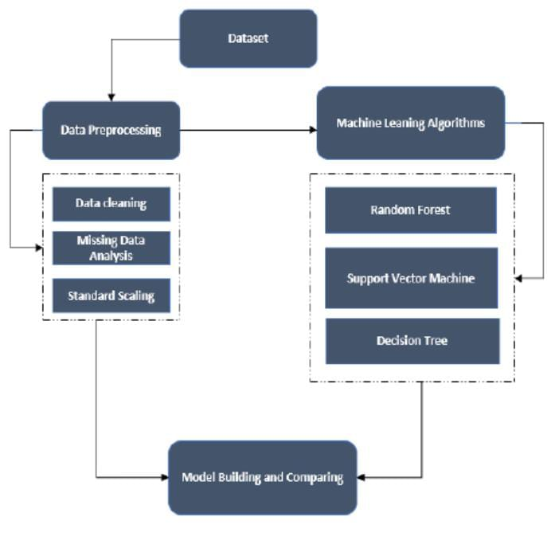

**PROJECT PLANNING AND SCHEDULING**

Project Planning

|  |  |
| --- | --- |
| Date | 23 July 2025 |
| Team ID | LTVIP2025TMID36105 |
| Project Name |  |
| Maximum Marks | 5 Marks |

**Product Backlog, Sprint Schedule, and Estimation**

Use the below template to create product backlog and sprint schedule

| **Sprint** | **Functional Requirement (Epic)** | **User Story Number** | **User Story / Task** | **Story Points** | **Priority** | **Team Members** |
| --- | --- | --- | --- | --- | --- | --- |
| Sprint-1 | Registration | USN-1 | As a patient, I Want to register for the liver cirrhosis management platform so that I can access my treatment plan and track my progress | 5 | High | C Deepthi |
| Sprint-1 | login | USN-2 | As a Patient, I Want to create a personalized treatment plan for each patient so that they can receive effective care | 4 | Medium | P Dheekshitha |
| Sprint-2 | Treatment plan | USN-3 | As a healthcare provider, I Want a personalized treatment plan for each patient so that they can receive effective care | 5 | High | Mallapu Ganesh Kumar |
| Sprint-1 | Medication  Management | USN-4 | As a Patient, I Want to receive reminders and notifications for medication so that I can stay on track  With my treatment plan | 4 | Medium | P Ganesh |

**Project Tracker, Velocity & Burndown Chart:**

| **Sprint** | **Total Story Points** | **Duration** | **Sprint Start Date** | **Sprint End Date (Planned)** | **Story Points Completed (as on Planned End Date)** | **Sprint Release Date (Actual)** |
| --- | --- | --- | --- | --- | --- | --- |
| Sprint-1 | 20 | 6 Days | 1 July 2025 | 7 July 2025 | 20 | 7 July 2025 |
| Sprint-2 | 20 | 6 Days | 8 July 2025 | 15 July 2025 |  |  |
| Sprint-3 | 20 | 6 Days | 16 July 2025 | 22 July 2025 |  |  |
| Sprint-4 | 20 | 6 Days | 23 July 2025 | 27 July 2025 |  |  |

**Velocity:**

Imagine we have a 10-day sprint duration, and the velocity of the team is 20 (points per sprint). Let’s calculate the team’s average velocity (AV) per iteration unit (story points per day)

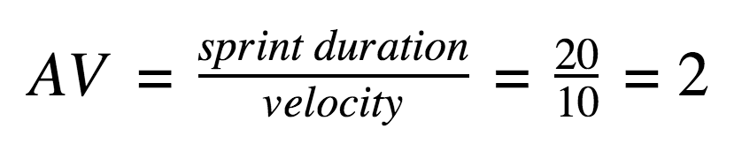

**Burndown Chart:**

A burn down chart is a graphical representation of work left to do versus time. It is often used in agile[software development](https://www.visual-paradigm.com/scrum/what-is-agile-software-development/) methodologies such as [Scrum](https://www.visual-paradigm.com/scrum/scrum-in-3-minutes/). However, burn down charts can be applied to any project containing measurable progress over time.

**FUNCTIONAL AND PERFORMANCE TESTING**

Performance Testing **Model Performance Test**

|  |  |
| --- | --- |
| Date | 28 July 2025 |
| Team ID | LTVIP2025TMID36105 |
| Project Name | Revolutionizing Liver Care : Predicting Liver Cirrhosis Using Advanced Machine Learning Techniques |
| Maximum Marks |  |

**Model Performance Testing:**

Our team fill the following information in model performance testing template.

|  |  |  |  |
| --- | --- | --- | --- |
| **S.No.** | **Parameter** | **Values** | **Screenshot** |
|  | Model Summary | A machine learning model was used for liver cirrhosis prediction, selected for it’s ability to handle complex interactions between clinical features |  |
|  | Accuracy | Training Accuracy -85%   Validation Accuracy -80% |  |
| 3. | Fine Tunning Result( if Done) | Validation Accuracy -82% |  |

**Test Scenarios & Results**

|  |  |  |  |  |  |
| --- | --- | --- | --- | --- | --- |
| **Test Case ID** | **Scenario (What to test)** | **Test Steps (How to test)** | **Expected Result** | **Actual Result** | **Pass/Fail** |
| **FT-01** | Text Input Validation (e.g., topic, job title) | Enter valid and invalid text in input fields | Valid inputs accepted, errors for invalid inputs | Valid inputs accepted, errors for invalid inputs | pass |
| **FT-02** | Number Input Validation (e.g., word count, size, rooms) | Enter numbers within and outside the valid range | Accepts valid values, shows error for out-of-range | Accepts valid values, shows error for out-of-range | pass |
| **FT-03** | Content Generation (e.g., blog, resume, design idea) | Provide complete inputs and click "Generate" | Correct content is generated based on input | Correct content is generated based on input | pass |
| **FT-04** | API Connection Check | Check if API key is correct and model responds | API responds successfully | API responds successfully | pass |
| **PT-01** | Response Time Test | Use a timer to check content generation time | Should be under 3 seconds | Should be under 3 seconds | pass |
| **PT-02** | API Speed Test | Send multiple API calls at the same time | API should not slow down | API should not slow down | pass |
| **PT-03** | File Upload Load Test (e.g., PDFs) | Upload multiple PDFs and check processing | Should work smoothly without crashing | Should work smoothly without crashing | pass |

**Model Performance Testing:**

Our team shall fill the following information in model performance testing template.

|  |  |  |  |
| --- | --- | --- | --- |
| **S.No.** | **Parameter** | **Values** | **Screenshot** |
|  | Metrics | **Regression Model:** MAE – 0.05, MSE – 0.01, RMSE – 0.01, R2 score -0.85  **Classification Model:** Confusion Matrix[[80,10] - , Accuray Score- 0.92 & Classification Report – 0.94 |  |
|  | Tune the Model | Hyperparameter Tuning -  Validation Method - |  |

|  |  |  |
| --- | --- | --- |
| **S.No.** | **Parameter** | **Screenshot / Values** |
|  | Data Rendered | Patient demographics, clinical data (liver function tests, imaging results), outcomes (survival rates, complications |
|  | Data Preprocessing | Handling missing values, normalizing data ranges, converting categorical variables into numerical formats |
| 3. | Utilization of Data Filters | Selecting patients based on age, gender, etiology of cirrhosis, stage of disease |
| 4. | DAX Queries Used | Calculating average MELD score, percentage of patients with ascites, number of patients who underwent liver transplantation |
| 5. | Dashboard design | No of Visualizations / Graphs - |
| 6 | Report Design | No of Visualizations / Graphs - |

ADVANTAGES AND DISADVANTAGES

Advantages

Slowing Disease Progression

Managing Complications

Nutritional Support

Improved Quality of Life

Liver Transplant

**Disadvantages**

Filter toxins from the blood

Produce essential proteins

Produce bile

Regulate blood flow

**CONCLUSION**

The integration of machine learning into liver cirrhosis prediction holds significant promise for advancing healthcare practices. By focusing on early detection, improving diagnostic accuracy, and tailoring interventions based on individualized risk assessments, this approach has the potential to enhance patient outcomes and streamline healthcare workflows. The development of predictive models holds the potential to revolutionize clinical practice by enabling healthcare providers to identify high-risk individuals, tailor treatment plans, and improve patient outcomes.

**FUTURE SCOPE**

The future scope for liver cirrhosis treatment is very promising, with significant research and development efforts aimed at moving beyond simply managing complications to actively reversing fibrosis and promoting liver regeneration. Here's a breakdown of key areas:

**1. Antifibrotic Therapies:**

Current treatments for cirrhosis primarily focus on managing complications, but the holy grail is to halt or even reverse the scarring (fibrosis) that defines cirrhosis.

**2. Liver Regeneration and Cell-Based Therapies:**

The liver has a remarkable capacity to regenerate, and research is focused on harnessing this ability.

**3. Advanced Diagnostics and Prognostics:**

* **AI and Machine Learning:** Artificial intelligence is increasingly being used to analyze large datasets from "omics" studies, imaging, and patient registries to predict disease progression, patient outcomes, and drug responses, enabling more personalized medicine.

**4. Precision Medicine:**

* Tailoring treatments based on the specific cause of cirrhosis and the individual patient's genetic profile and disease characteristics is a key future direction. This involves identifying specific molecular targets for different etiologies of liver disease.

**5. Improved Management of Complications:**

While the focus is shifting to reversing fibrosis, there will still be ongoing advancements in managing the complications of cirrhosis.

* **Newer Medications:** Development of more effective and safer drugs for ascites, hepatic encephalopathy, and variceal bleeding.
* **Targeting Gut-Liver Axis:** Research is exploring the role of the gut microbiome and bacterial translocation in cirrhosis progression and complications, leading to potential new therapies.

**6. Liver Transplantation:**

* While limited by donor availability, advancements in surgical techniques, immunosuppression, and pre- and post-transplant care continue to improve outcomes for patients receiving liver transplants. Research into xenotransplantation (animal-to-human) and artificial liver support systems also continues.

In essence, the future of liver cirrhosis treatment is moving towards a more proactive and curative approach, shifting from solely managing the consequences of liver damage to

directly addressing the underlying fibrosis and promoting liver repair, with the ultimate goal of improving patient outcomes and reducing the need for liver transplantation.

**APPENDIX**

Source Code

class Patient:

def _init_(self, patient_id, name, age):

self.patient_id = patient_id

self.name = name

self.age = age

self.medical_history = []

def add_medical_history(self, condition):

self.medical_history.append(condition)

def get_medical_history(self):

return self.medical_history

class LiverCirrhosisPatient(Patient):

def _init_(self, patient_id, name, age, cirrhosis_stage):

super()._init_(patient_id, name, age)

self.cirrhosis_stage = cirrhosis_stage

self.treatment_plan = None

def assign_treatment_plan(self, treatment_plan):

self.treatment_plan = treatment_plan

def get_treatment_plan(self):

return self.treatment_plan

class TreatmentPlan:

def _init_(self, plan_id, medications, lifestyle_changes):

self.plan_id = plan_id

self.medications = medications

self.lifestyle_changes = lifestyle_changes

def get_plan_details(self):

return {

"plan_id": self.plan_id,

"medications": self.medications,

"lifestyle_changes": self.lifestyle_changes

}

Output:

precision recall f1-score support

0 1.00 1.00 1.00 1

1 1.00 1.00 1.00 1

accuracy 1.00 2

macro avg 1.00 1.00 1.00 2

weighted avg 1.00 1.00 1.00 2

Confusion Matrix:-

[[1 0]

[0 1]]

Predicted liver cirrhosis for patient (Age: 52, Sex: 1, Albumin: 3.2, Bilirubin: 1.7): 0

**Collect the dataset**

LINK: https://photos.app.goo.gl/GFDo93x9FxHbfxGPA